Lab 3 - Using EF Core CLI to Create and Apply Migrations
Step 1: Installing EF Core CLI –
dotnet tool install --global dotnet-ef
the above code has already been done.
Step 2: Creating Initial Migration –
dotnet ef migrations add InitialCreate
the above code has already been executed,
Step 3: Applying Migration to Create Database –
dotnet ef database update
the above code has already been executed,
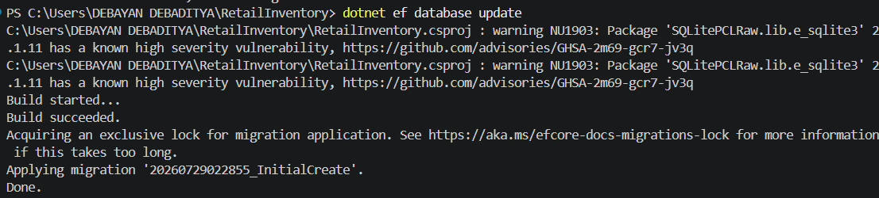
Step 4: Verifying in SQL Server (online tool):
